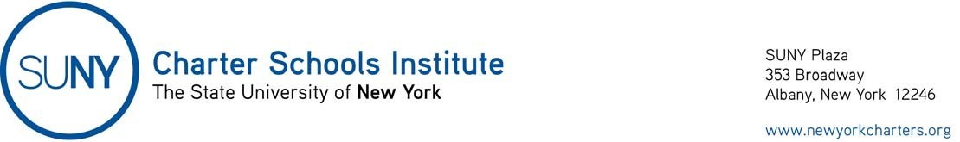
April 10, 2020

Parent Transportation Requests

Governor’s Executive Order 202.15 (https://www.governor.ny.gov/sites/governor.ny.gov/files/atoms/files/EO_202.15.pdf ), dated April 9, 2020, extends the April 1st deadline to submit requests for transportation for the 2020-21 school year to school districts until May 9, 2020. This means parents may submit requests at any time through May 9th. Executive Order 202.15 leaves unchanged the other parts of New York Education Law subdivision 3635(2).

